Lat,lon | Linear | SVR | RandomForest | LSTM | Auto
LR 0.01 | 4.705532 | 11.716228 | 11.171598 | 15.537462 | 18.98628
LR 0.001 | 4.705532 | 11.716228 | 11.171598 | 9.722260 | 12.340163
LR 0.0001 | 4.705532 | 11.716228 | 11.171598 | 6.52408 | 8.697984

lat | Linear | SVR | RandomForest | LSTM | Auto
LR 0.01 | 4.318212 | 11.192576 | 6.167516 | 10.261312 | 14.50184155
LR 0.001 | 4.318212 | 11.192576 | 6.167516 | 8,955675 | 7.53451824
LR 0.0001 | 4.318212 | 11.192576 | 6.167516 | 10.551813 | 6.03197336

lon | Linear | SVR | RandomForest | LSTM | Auto
LR 0.01 | 5.092851 | 12.239881 | 6.959910 | 11.328125 | 24.90682602
LR 0.001 | 5.092851 | 12.239881 | 6.959910 | 9.807904 | 7.50735950
LR 0.0001 | 5.092851 | 12.239881 | 6.959910 | 7.504241 | 5.90960455
LR 0.00001 | 5.092851 | 12.239881 | 6.959910 | 6.346209 | 5.86

Alt | Linear | SVR | RandomForest | LSTM | Auto
LR 0.01 | 861.621307 | 925.540455 | 771.758089 | 921.994690 | 831.31738281
LR 0.001 | 861.621307 | 925.540455 | 771.758089 | 1014.161560 | 984.99353027
LR 0.0001 | 861.621307 | 925.540455 | 771.758089 | 851.897522 | 871.67822266

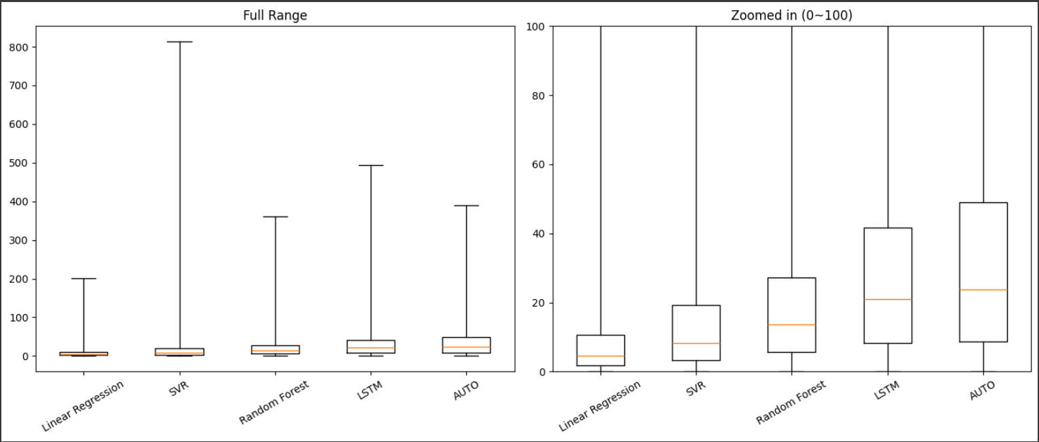

LR 0.001

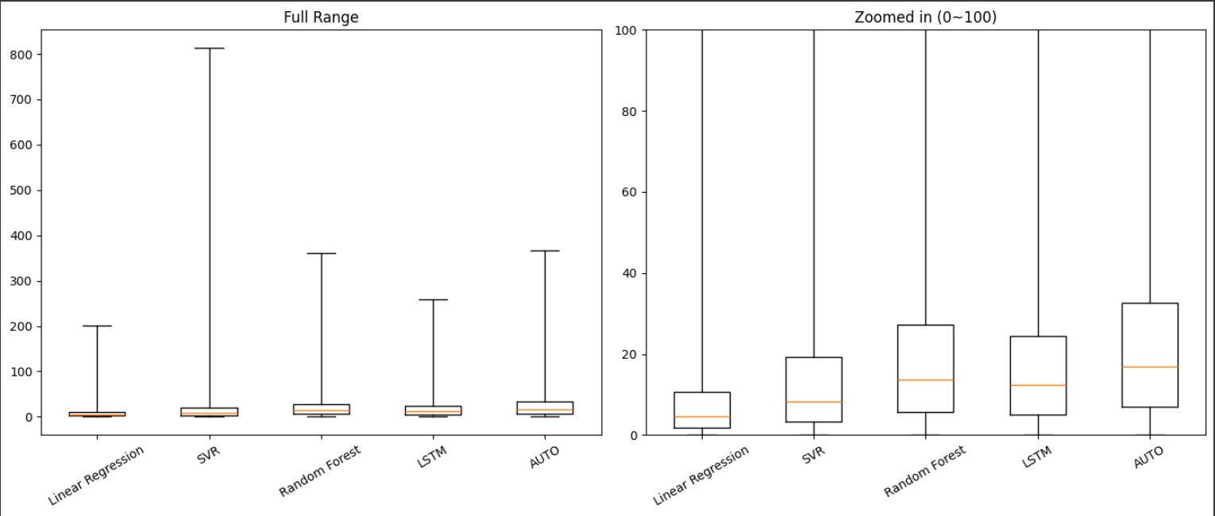
LR 0.0001
